Executive Summary
The purpose of the document is to review the 2024 CPFR Roadmap. This document, to be reviewed yearly, informs leadership the pain points from the previous year, yearly goals for CPFR, and the roadmap to achieve milestones. We aim to ensure alignment of our 2024 goals with the overarching direction of the IMPACT organization. These initiatives will simplify and enhance the company-wide vendor data share, further integrate with cross-verticals (Vendor Compliance, Transportation and Merch), and, with PM&A integration, build internal tools and processes that work in-tandem with CPFR data share.

Current-State
In 2023, CPFR underwent advancements, setting the stage for its vision in 2024. We launched on the long-term platforms VDS Premium and initiated two VDS Direct feeds for inventory and forecast, covering six vendors. Additionally, we are scoped to launch on VPP in 24/25. We've implemented an ongoing leadership steering committee to ensure new data is reviewed before releasing. The released data facilitated collaboration with vendors, enabling the establishment of processes for forecast reconciliation, weekly business reporting, NOP exceptions, ASBO impacts, and catalog reconciliation. This collaboration organically segmented vendors into three tiers based on shared data, processes, and engagement levels, providing a framework for future leveraging.

Progression and Learnings
In Year 1 & 2, we quickly expanded CPFR to 50+ vendors, launched data/systems/processes for demand and supply planning to action, leveraged current systems and received stakeholder input. The lessons learned throughout this process shaped our vision this year, Year 3, which has a primary focus on data sharing enhancements, overall engagement strategy, and integration with PM&A. Key learnings from 2023:
- We need a more defined IMPACT framework for sharing operational data externally (VDS vs VPP vs Knime vs Python vs EDI vs API). We need to optimize our systems, provide internal visibility into reports sent, and corresponding internal/external SOPs for stakeholders to leverage.
- The CPFR program has expanded its report portfolio and has several more in development. Throughout this growth, some vendors have demonstrated superior data utilization compared to others. Establishing a framework to evaluate best practices enables us to scale insights, innovate new tools, and outline actionable next steps.
- Integration with the Impact Command Center (ICC) is essential for visibility into the reports sent, access to the reports, and corresponding SOPs to fully leverage operational data.
- Optimizing the VDS platform will not only attract new customers to both Premium and Direct services but also introduce new and enhanced dashboards for operational reporting. Additionally, it will empower Chewy stakeholders to utilize the platform effectively within the Impact Command Center.
- To meet the demands of upcoming enhancements, we must refine our engagement strategy. We require more effective methods for requesting and monitoring new data, sharing best practices, and soliciting feedback.

2024 Themes
Enhance short and long-term systems to unlock insights and visibility. CPFR currently employs Knime, Python, and VDS for data sharing. However, there's a recognized need to enhance our existing data sharing infrastructure to unlock additional capabilities. Over the short term (0-1 years), CPFR aims to enhance non-VDS data sharing to increase flexibility and transparency (refer to Appendix 1.0 for a detailed breakout). These features unlock widespread adoption, report consolidation, report transparency, and review mechanisms to scale vendors. We will continue to enhance VDS Premium/Direct throughout the year. In the long-term, we are coordinating with VPP on overall data sharing strategy and phased releases in 24/25.

A more compressive data/systems paper will be socialized once VPP alignment is completed.

Strategic focus and tiering on top performing CPFR vendors for maximum value. CPFR observed the greatest incremental gains with strategic vendors possessing the scale, infrastructure, and active engagement necessary to optimize operations. Lessons learned and successful strategies from initiatives such as vendor dashboard creations, exception reporting, forecast/supply processes, NOP investigation, and WBRs can be effectively scaled to benefit others. To further enhance this structure, segmenting vendors into three tiers (Strategic, Intermediate, and Basic) has been proposed, each with defined data and processes. This segmentation facilitates two key capabilities: 1.) Peer review within Tier 1&2 to identify opportunities for improvement and scalability, and 2.) Strategic discussions with targeted vendors to improve their tiering ranking and drive overall progress.
Enhancing vendor strategies through ICC integration. CPFR will improve integration with everyday planning activities by providing stakeholders with a centralized platform to access and incorporate CPFR reports into their routines. Through integration with the ICC, all VDS and CPFR reports will be displayed, allowing stakeholders to align on reporting standards and callout criteria to leverage vendor-owned insights. Moreover, this integration enables the introduction of new forecasting and supply reports/tools for predictive insights and process enhancements.

Maximize value on VDS Premium and VDS Direct for increased adoption and analytics. In 2023, CPFR launched significant milestones on VDS Premium and Direct platforms. It facilitated Tableau reporting and enabled system-to-system data sharing via the cloud, marking a substantial leap forward in data accessibility and collaboration capabilities. The planned upgrades will increase Merch’s bargaining power during negotiations, enhance mutual reporting and insights, and propel us towards a comprehensive data collaboration hub.

Enhanced organizational involvement and visibility towards achieving a best-in-class CPFR Program. CPFR integrates various mechanisms such as data steering committees, planner connects, surveys, and a structured intake process for data requests. To bolster our approach, we aim to introduce and enhance additional mechanisms on a defined schedule, fostering active involvement of stakeholders in providing feedback, evaluating progress, and embracing innovations. By incorporating these elements into the CPFR calendar, we enhance transparency in our engagement strategy, thereby boosting the effectiveness of the CPFR Program.

2024 Deliverables
- Launch upgraded email system. CPFR will streamline operational reporting by consolidating onto a single email system. This consolidation will provide visibility into sent reports, documentation, and SOPs, as well as establish an organizational workflow for launching new data upon request.
- Optimize VDS Premium. Several upgrades are in the pipeline, encompassing new data and Tableau views to meet the requirements of WBR reporting, enabling alignment on criteria and empowering vendors to manage callouts and reporting.
- Expand VDS Direct content. Plans include scoping 2-3 additional feeds for NOP, ASBO, and vendor compliance, enriching the offering for Merch during negotiations and facilitating CPFR integration.
- Report Integration and Optimization. Integrate into the Impact Command Center for visibility into reports, ad-hoc data pulls, report requests, and daily operational activities.
- CPFR Vendor Tiers. Implementation of three tiers for CPFR vendors will facilitate the review of tier-specific criteria, best practices, and necessary improvements to meet standards, allowing for rating based on progression and the addition of new vendors.
- Expand scope to Vendor Compliance and Transportation data. CPFR will integrate current reporting and collaborate with teams on new reports for enhanced insights and exception reporting.
- Define SOPs on CPFR processes like Catalog and Forecast reconciliation. Each CPFR report will have an internal and external SOP for stakeholders to leverage.
- Establish a systematic approach for requesting and launching new data/reports over the long term. Develop an IMPACT process for requesting new data and reports, which includes tracking progress and obtaining decisions from the steering committee.
- Top of Form

- Enhance Internal Merch Engagement. Given the proposed upgrades, we can leverage the CPFR program with Merch teams to target potential VDS vendors, onboard strategic accounts, and possibly leverage the data in future negotiations.

Final Thoughts
The vision of CPFR is to be the #1 industry leading and comprehensive destination for all Pet Partners to plan/action operations, enhance collaborative synergies, and identify insights. With this goal in mind, we are confident that the initiatives outlined will deliver significant benefits in 2024. Stakeholders will have enhanced visibility and accessibility to all operational reports, receive alerts prompting engagement when necessary, and utilize SOPs with vendors to expedite insights.

Dogs Barking – Hot Topics
This section is intended to discuss topics and get feedback on overall initiatives.
- Are you aligned to differentiate CPFR content by Tier or Report? (see appendix 1.0)
- CPFR proposes a quarterly recurring Tier 1/2 review and ranking on processes. (see appendix 1.1)
- I think it’s a natural transition for CPFR to include Vendor Compliance and Transportation data to holistically report on the supply chain, uncover key drivers, and report on end-to-end supply chain data.

Appendix 1.0 – Data Sharing Systems
In year 1, the CPFR program maintained a consistent data sharing model across all CPFR vendors (3 reports). In the most recent year, we introduced new reports such as NOP, ASBO, and Catalog details to select vendors. We are currently at 7 reports, with several more scoped for the future. The current framework allows CPFR to share select reports with strategic vendors. Given stakeholder feedback, we want to enhance our data sharing systems to allow for more flexibility in the reports sent. Below, we outline two proposed models for system upgrades.

Model 1 (preferred): We propose segmenting the CPFR data share into 3-4 tiers based on report types. Currently, Tiers 1,2 and 4 exist today. However, today, the data sharing system is not uniform and different delivery systems are used. Our objective is to implement an email data sharing system that meets the requirements of CPFR, Vendor Compliance, and Transportation. We envision this model as a means for IMPACT to centralize external reporting onto a single platform. This structure will empower leaders to designate reports within each tier, offer organizational transparency regarding sent reports, and facilitate the scalable implementation of CPFR throughout the organization.

Model 2: Enhanced flexibility in data sharing can be achieved by allowing stakeholders to select the specific types of reports to be transmitted to vendors. However, after consideration, we opted against this approach. Managing a variety of reports from vendors could potentially introduce confusion for planners and lead to inconsistent expectations. Additionally, this method would not enable CPFR to establish clear criteria and expectations for each tier, limiting our ability to ensure alignment and efficiency across the program.

Long-Term: The VPP team is currently evaluating the structure of the CPFR data share for their forthcoming Phased plan, with future meetings scheduled to finalize decisions regarding large-scale data sharing initiatives. Forecast will be the first to launch once Socrates transition is complete.

Appendix 1.1 – CPFR and ICC Feedback loop
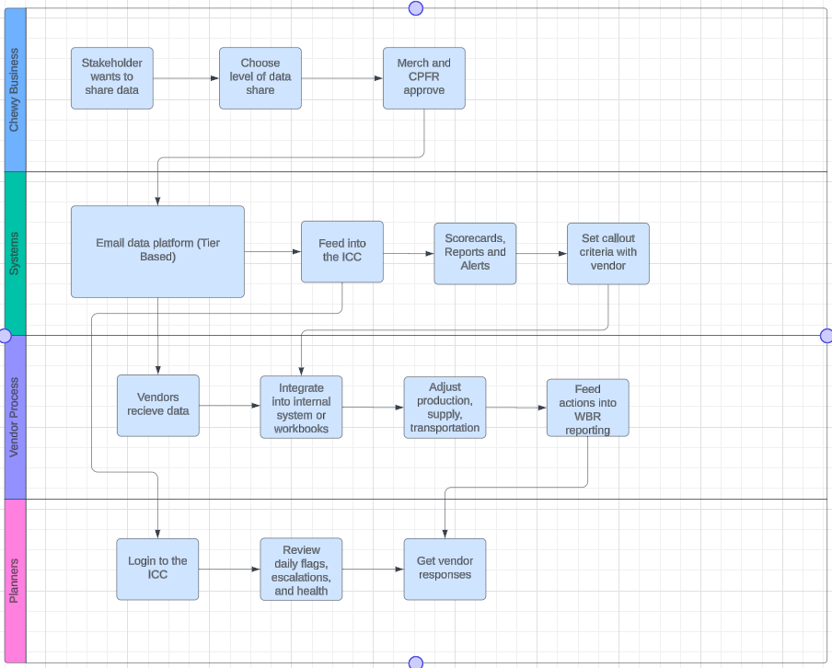

Appendix 1.2 – Vendor Tiering and Data Share
The CPFR data sharing system currently operates across three Tiers: Strategic, Intermediate, and Basic. Within each tier, a set of "best operating practices" is established, offering a framework for improving vendor performance within the same tier. This approach has proven successful in various activities such as monthly forecast reconciliation meetings, vendor dashboard integration, NOP exceptions and reporting, and supply reporting. However, CPFR lacks a structured mechanism for reviewing and ranking best practices across its numerous activities.

Example subset:
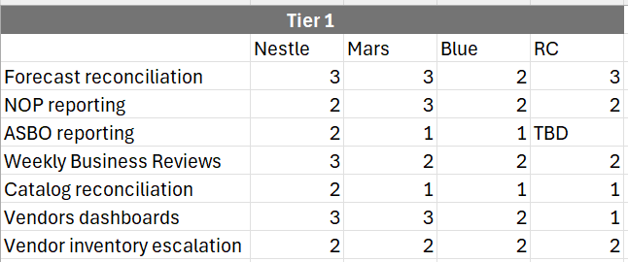
*** 3 = Fully Optimized
2 = Doing well, room for improvement
1 = Just receiving the data

Appendix 1.3- ICC Integration: The Impact Command Center layout will work in tandem with CPFR. For instance, within the ICC, planners will find a comprehensive workflow designed to oversee and optimize business operations. This includes reviewing overall business performance through scorecards, pinpointing focus areas with Brand/SKU overviews, identifying anomalies and repeat offenders through exception reporting, and accessing SKU-level data. The ICC structure empowers planners to tailor conditions and filters according to their specific business requirements. Planners will communicate the conditions and filters for review, and vendors will own the reporting back to Chewy.

Appendix 1.4 – Long-Term CPFR Vision
Walkthrough - Stakeholders assess business needs to determine the most suitable data share for vendors, submitting requests to CPFR for vendor onboarding. After review by Merch/SC, CPFR finalizes vendor enrollment. The ICC provides comprehensive visibility into CPFR vendors including reports sent, documentation, recipients, and assigned Tier (1-3).

Operational data from VDS vendors is maximized through both Premium and Direct channels. These VDS reports are integrated into the ICC, enabling automated WBRs with customizable conditions. We will launch VPP for large-scale data distribution.

The data scope will increase to Vendor Compliance and Transportation data to offer a centralized location for operational reporting. CPFR vendors will be categorized into three tiers and evaluated based on best-in-class practices. This classification will provide transparency regarding CPFR's prioritization of time and resources to enhance vendor rankings and progress. The roadmap to achieving best-in-class status will be outlined in SOPs for each report. These SOPs will serve as comprehensive guides for stakeholders, detailing the data, reporting procedures, exception handling, and corresponding steps to follow.

Appendix 1.5– CPFR Reports
Report 1: Forecast
Report 2: Inventory (Main CPFR Report)
Report 3: Fill-Rate/PDPOOS
Report 4: NOP
Report 5: NOP Exception Reporting
Report 6: ASBO Reporting
Report 7: Catalog Details
Report 8: WoW and MoM data for Fill-Rate and PDPOOS- Future
Report 9: Scorecards- Future
Report 10: PO Details - Future
Report 11: Vendor Compliance – Future (need to integrate all VC reports)
Report 12: Transportation – Future (need to assess data metrics)
Report 13: On-Time - Future
Report 14: WoW Changes for escalation – Future
Report 15: Socrates Purchase Forecast- Future

